**CHAPTER 1**

**1. INTRODUCTION**

Rice is one of the most important staple crops in the world, providing a significant source of food for billions of people. However, paddy leaf diseases have become a major threat to the quality and yield of rice crops. Early detection of paddy leaf diseases is crucial in preventing significant losses in crop yield and quality. Traditional methods of detecting paddy leaf diseases rely on manual inspection, which is time-consuming and prone to errors. In recent years, image processing techniques have emerged as a promising solution for the early detection of paddy leaf diseases. Image processing allows for the automated detection and diagnosis of paddy leaf diseases, which can significantly reduce the time and effort required for disease detection. The proposed method involves capturing images of paddy leaves using a digital camera, followed by image pre-processing, feature extraction, and classification. Image pre-processing involves various image enhancement techniques to improve the quality of the images, while feature extraction involves extracting relevant features from the pre-processed images. The proposed method uses grey level cooccurrence matrix (GLCM) and local binary pattern (LBP) to extract texture features from the images. Finally, a support vector machine (SVM) is used as a classifier to identify the type of paddy leaf disease. The proposed method has the potential to revolutionize the way paddy leaf diseases are detected and diagnosed. By providing a fast, accurate, and reliable tool for the early detection of paddy leaf diseases, the proposed method can help farmers make informed decisions about crop management, leading to increased crop yields and improved food security**.**

## SCOPE OF THE PROJECT

The scope of the project for paddy leaf disease detection using image processing is to develop an accurate and efficient system for automated detection and classification of paddy leaf diseases. The project aims to improve the diagnosis of paddy leaf diseases, which will aid farmers in the timely detection and management of the diseases, ultimately leading toincreased crop yield andimproved food security.

**1.2 OBJECTIVE**

* To detect paddy leaf disease portion from image.
* To extract features of detected portion of leaf.
* To recognize detected portion of leaf through SVM (Support Vector machine)

**1.3 REPORT SUMMARY**

The project report is organized as follows: the chapter 2 narrates the related work done in this Paddy Leaf Diseases Detection, chapter 3 explains the existing system, chapter 4 depicts the architecture and design of the proposed methodology, chapter 5 discuss the system implementation requirements, chapter 6 describes the simulation and discussion for the Paddy Leaf Disease Detection, the chapter 7 details the conclusion and future work of this the Paddy Leaf Disease Detection,, and the last section provides the references and appendix.

**CHAPTER 2**

# LITERATURE SURVEY

## 2.1 INTRODUCTION

The various research works on the existing paddy leaf disease detection using image processing are discussed and analysed.

### 2.1.1 Detection of bacterial leaf blight in rice using machine learning and image processing techniques

### by M. S. Al-Tameemi et al. at (2021) :

This study proposed a machine learning-based approach for the automated detection of bacterial leaf blight in rice plants using image processing techniques. The authors used texture analysis and color-based features to extract relevant information from the images, and trained a support vector machine (SVM) classifier to distinguish between healthy and diseased leaves. The proposed approach achieved an accuracy of 91.6% on a dataset of 200 images, demonstrating its potential for practical applications.

### 2.1.2 Identification of Paddy Leaf Diseases using Image Processing Techniques by S. R. Santhi and P.Ramachandran (2020) :

This study proposed a system for the identification of paddy leaf diseases using image processing techniques, including segmentation, feature extraction, and classification. The authors used a dataset of paddy leaf images to evaluate the proposed system, achieving high accuracy for disease detection.

## 2.1.3 Paddy Leaf Disease Detection and Classification Using Image Processing Techniques and Neural Networks

## by M. R. Islam et al. (2019):

This study proposed a system for paddy leaf disease detection and classification using image processing techniques and neural networks. The authors used a dataset

**2.1.4 Detection and classification of rice leaf diseases using deep convolution neural networks**

by Z. Jiang et al. (2018):

This study proposed a deep learning based approach for the automated detection and classification of five major paddy leaf diseases using convolutional neural networks (CNNs). The authors used a dataset of 1,122 images and trained a CNN model to classify the images into healthy and diseased classes. The proposed approach achieved an overall accuracy of 95.2%, demonstrating the potential of deep learning techniques for paddy leaf disease detection.

**2.1.5 Paddy Leaf Disease Detection Using Image Processing Techniques**

by P. Subramanian et al at (2017):

This review article provides a comprehensive overview of image processing techniques for paddy leaf diseases detection, including segmentation, feature extraction, classification, and validation. The authors highlight different methods and algorithms used in the literature, such as thresholding, morphological operations, texture analysis, and machine learning, and compare their advantages and limitations.

## 2.1.6 Automated Detection of Paddy Leaf Diseases Using K-means

## Clustering and Support Vector Machines

by S. B. S. Kumar et al. at (2016):

This paper proposes an automated. The authors show that their system achieves high accuracy and sensitivity in detecting and classifying four common paddy leaf diseases, namely brown spot, bacterial leaf blight, blast, and sheath blight, and outperforms other methods, such as colour-based segmentation and texture analysis.

**CHAPTER 3**

**EXISTING SYSTEM**

# 3.1 Paddy Leaf Diseases Detection

The existing system for paddy leaf disease detection typically involves manual visual inspection by trained professionals in the field, who visually examine the leaves for any signs of disease, such as discoloration, necrosis, or lesions. This method is time-consuming, subjective, and prone to errors and misdiagnosis, especially for early stages or subtle symptoms of diseases. Moreover, it requires expertise and resources, which may not be available or accessible to all farmers or regions.

Therefore, there is a growing interest in developing automated and objective systems for paddy leaf disease detection using image processing techniques. These systems involve capturing digital images of paddy leaves using cameras or smartphones, pre-processing and enhancing the images, segmenting the regions of interest, extracting relevant features and patterns, and classifying the images into healthy or diseased categories using machine learning algorithms. Some existing systems use colour-based segmentation, texture analysis, or Support vector machine (SVM), to achieve high accuracy and robustness in disease detection. However, these systems also face challenges, such as image quality, lighting, background noise, and dataset bias, which require careful consideration and optimization**.**

The manual inspection system for paddy leaf disease detection has several limitations, including low efficiency, low accuracy, and subjective interpretation. It also requires skilled labour, which may not be available in remote or underdeveloped areas. Moreover, it is difficult to detect diseases at an early stage when visual symptoms are not yet apparent. These factors can lead to delayed treatment, increased crop damage, and decreased yield.

To address these limitations, various automated systems for paddy leaf disease detection have been developed using image processing techniques. These systems can quickly and accurately identify the presence of diseases in paddy leaves, allowing for early intervention and effective disease management. The automated system can also reduce the need for skilled labour and facilitate rapid and objective decision-making.

Some of the existing systems for paddy leaf disease detection use colour-based segmentation methods to isolate the regions of interest from the background. The colour-based methods are based on the observation that healthy and diseased leaves exhibit different colour variations, which can be exploited to distinguish between them. Other systems use texture analysis methods to extract texture features from the images, which can be used to differentiate between healthy and diseased leaves. Deep learning methods, such as Support vector machine (SVM)have also been used to classify the images into healthy or diseased categories.

However, these systems also face some challenges, such as variability in image quality, lighting conditions, and environmental factors. The performance of the system can also be affected by the size and quality of the dataset used to train the machine learning algorithms. Hence, careful consideration of these factors is essential to develop a robust and effective automated system for paddy leaf disease detection.

Overall, the existing systems for paddy leaf disease detection using image processing techniques have shown promising results in terms of accuracy, efficiency, and objectivity. However, further research is needed to optimize these systems for real-world applications and to address the challenges faced by these systems**.**

# 3.2 Literature Conclusion

The literature on paddy leaf disease detection using image processing techniques shows that there is a growing interest in developing automated and objective systems for detecting diseases in paddy leaves. These systems can help to overcome the limitations of manual inspection, such as low efficiency, low accuracy, and subjective interpretation. Moreover, they can facilitate early detection and intervention, which can help to reduce crop damage and increase yield.

The literature also reveals that various image processing techniques, such as colour-based segmentation, texture analysis, and deep learning methods, have been used to develop automated systems for paddy leaf disease detection. These systems have shown promising results in terms of accuracy, efficiency, and robustness. However, they also face challenges such as variability in image quality, lighting conditions, and dataset bias, which require careful consideration and optimization.

In conclusion, the literature suggests that image processing techniques have the potential to revolutionize paddy leaf disease detection by enabling rapid, objective, and accurate diagnosis. However, further research is needed to optimize these systems for real-world applications, to address the challenges faced by these systems, and to make them accessible to farmers in remote or underdeveloped areas.

**CHAPTER 4**

**PROPOSED WORK**

## 4.1 PADDY LEAF DISEASE CLASSIFICATION

Fig 4.1

Proposed

Model

Flow



Load image



Image

Segmentation



Feature

Extraction



Feature

Selection



Classification



Result



SVM

### 4.1.1 Image Segmentation

Image segmentation using active contour is a technique used to separate objects in an image from its background. It works by assigning energy values to each pixel and then utilizing the principles of calculus and optimization techniques to determine the optimal path or boundary around the object of interest. This method can be applied to any type of image including medical imaging, satellite imagery, aerial photography, etc., allowing for automatic extraction and analysis of regions-of-interest within images with high accuracy. Active contours are particularly useful when dealing with complex shapes that may not be easily separated using traditional methods such as thresholding or edge detection algorithm.

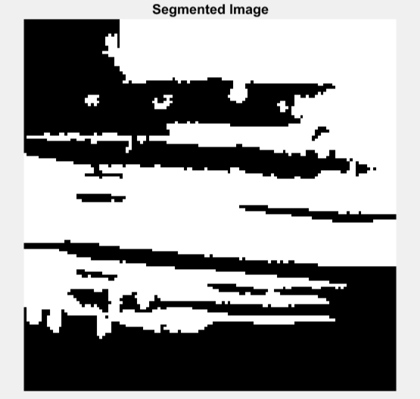

Fig 4.2 Segmented image

### 4.1.2 Feature Extraction

Feature extraction is the process of taking raw data and extracting meaningful features from it. It involves identifying important characteristics or patterns in a dataset that can be used to summarize or represent the data more effectively. Feature extraction techniques are commonly used for tasks such as image recognition, text analysis, natural language processing, and machine learning models. By reducing the dimensionality of a dataset through feature extraction methods like Principal Component Analysis (PCA), we can make our models faster to train while still obtaining accurate results.

### 4.1.3 Feature Selection

Feature selection using PCA is a powerful technique for reducing the dimensionality of data and selecting the most important features. It works by finding linear combinations of existing variables that explain most of the variance in a dataset. By removing redundant or irrelevant features, it can reduce noise and improve model performance. Furthermore, feature selection with PCA can help identify interactions between different variables which may be difficult to uncover otherwise. In summary, this method provides an efficient way to select meaningful features from large datasets while preserving their underlying structure at the same time.

### 

### 4.1.4 SVM

Support Vector Machines (SVM) is a type of supervised machine learning classification algorithm that can be used to classify data into two or more classes. It draws a hyperplane between the different classes and classifies new examples based on which side of the plane they fall on. SVMs are particularly effective in cases where there is clear margin of separation between different classes, and when there are large amounts of data available for training. They have been widely applied to various fields such as image recognition, text categorization, bioinformatics and hand-written character recognition.

**4.1.6** **Dataset Description**

The dataset used in the project for Paddy leaf disease detection using image processing typically contains digital images of paddy leaves affected disease present in each image. The dataset may also include images of healthy paddy leaves for comparison and validation purposes. The size of the dataset can vary depending on the specific needs of the project, but larger datasets with a diverse range of samples can improve the accuracy and robustness of the detection system. The dataset can be obtained through various sources such as online repositories, research institutions, and agricultural organizations. It is important to ensure that the dataset is well-labelled, high-quality, and relevant to the specific research question being addressed.

In This Project we Take Four paddy leaf diseases dataset they are:

• Bacterial Blight • Leaf Blast

• Leaf Smut • Brown Spot

### CHAPTER 5

### 5.1 Methodology

The main objective of this process is to improve image data. It consist resizing image and image segmentation. The image resizing operation is required for various purposes such as display, storage and transmission of images. Image segmentation is the process of partitioning a digital image into multiple segments. The goal of segmentation is to simplify and change the representation of an image into something that is more meaningful and easier to analyse. It consist image acquisition, image pre-processing and segmentation, feature extraction and classification.

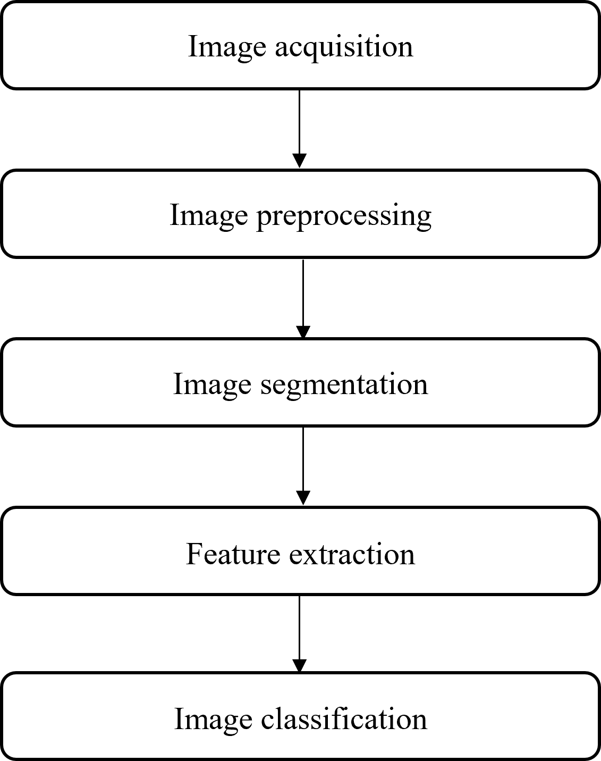

Fig 4.3 Methodology

**5.2 FLOW CHART**

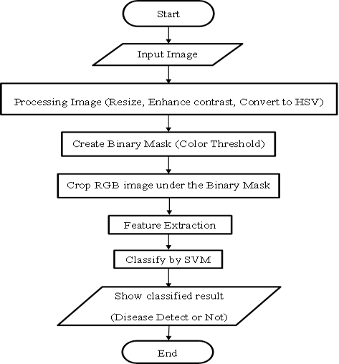

Fig 4.4 Flow chart

# CHAPTER 6

# SYSTEM SPECIFICATION

## 6.1 Software Requirement

Table 6.1 Software Specifications

|  |  |  |  |
| --- | --- | --- | --- |
| S. No | Software | Version | URL |
| 1 | MATLAB  R2018a | 9.4 | https://in.mathworks.com/products/matl ab.html |

### 6.1.1 MATLAB

MATLAB is a high-level programming language and interactive environment for numerical computation, visualization, and programming. It allows users to analyse data, develop algorithms, and create models and applications. MATLAB provides a wide range of mathematical functions for linear algebra, statistics, Fourier analysis, filtering, optimization, and more. It also includes a graphical user interface for easy visualization of data and results. MATLAB is commonly used in engineering, science, and finance fields for data analysis and modelling.

## 6.2 Hardware Requirement

Table 6.2 Hardware Specification

|  |  |
| --- | --- |
| Laptop or PC |  |
| Processor | Intel Core i3 |
| Operating System | Windows 10,11 (64-bit) |
| RAM | 8 GB |

## 6.3 Installation procedure

The installation procedure for MATLAB can vary depending on your operating system. Here are the general steps for installing MATLAB:

**Step 1** **-** Go to the MathWorks website (www.mathworks.com) and create an account if you do not already have one.

**Step 2 -** Log in to your account and navigate to the MATLAB download page.

**Step 3 -** Choose the version of MATLAB you wish to download and click on the appropriate download link for your operating system.

**Step 4 -** Follow the prompts to download the MATLAB installer file to your computer.

**Step 5 -** Once the download is complete, locate the installer file on your computer and double-click it to begin the installation process.

**Step 6 -** Follow the on-screen prompts to complete the installation process. You may be asked to enter your MathWorks account information and product key.

**Step 7 -** Once the installation is complete, launch MATLAB to verify that it is working properly.

# CHAPTER 7

# IMPLEMENTATION

**Dataset Preparation:**

The first step in implementing this project in MATLAB is to prepare the dataset of paddy leaf images. The dataset should include both healthy leaves and leaves infected with different types of diseases, such as blast, bacterial leaf blight, and brown spot. The images should be pre-processed to ensure that they are of high quality and resolution.

**Image Processing:**

The next step is to perform image processing tasks such as image enhancement, segmentation, and feature extraction. This can be done using built-in functions in MATLAB such as imadjust, imbinarize, and extract HOG Features. These functions can be used to enhance the images, segment the leaves from the background, and extract features such as texture and shape information.

**Machine Learning:**

Once the images have been pre-processed, the next step is to train and test machine learning models to classify the images into healthy leaves or leaves infected with different types of diseases. In MATLAB, this can be done using the function to train a support vector machine (SVM) model These models can be evaluated using metrics such as accuracy,precision, recall, and F1-score, which can be calculated using the confusion and classification Report functions in MATLAB**.**

**User Interface:**

Finally, a user interface can be developed to provide an interactive way for users to input an image of a paddy leaf and get the diagnosis of whether it is healthy or infected with a specific disease. This can be done using MATLAB's App Designer or GUI Development Environment.

Overall, implementing this project using MATLAB requires a good understanding of image processing and machine learning concepts, as well as proficiency in MATLAB programming. With the right tools and techniques, MATLAB can be a powerful tool for developing an automated system for paddy leaf disease detection.

The result of this project would be an automated system for detecting paddy leaf diseases using image processing and machine learning techniques. The system would be able to accurately classify paddy leaf images as healthy or infected with a specific disease, such as blast, bacterial leaf blight, or brown spot.

The performance of the system would be evaluated using metrics such as accuracy, precision, recall, and F1-score. These metrics would indicate how well the system is able to correctly classify paddy leaf images and distinguish between healthy and diseased leaves. The performance of the system can also be visualized using confusion matrices and classification reports.

The result of the project would demonstrate the effectiveness of using image processing and machine learning techniques for detecting paddy leaf diseases. It would provide a fast, accurate, and reliable method for farmers and researchers to diagnose and treat paddy leaf diseases, ultimately leading to better crop yields and increased food security.

# CHAPTER 8

# RESULT

**DATASET COLLECTED**

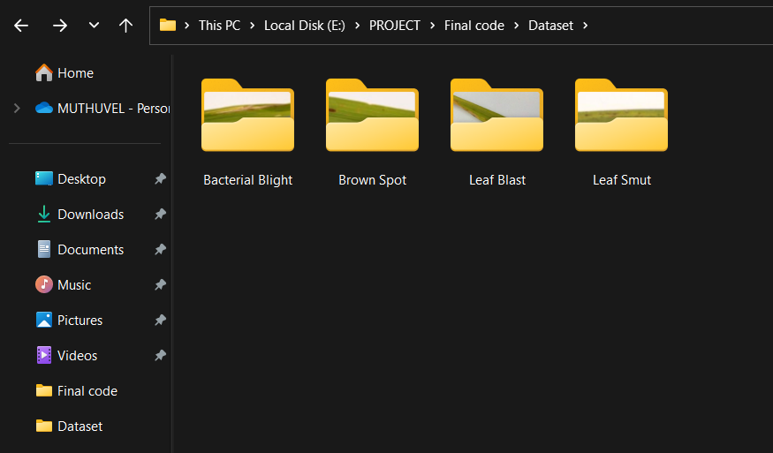

Fig 8.1 Dataset collected

The databases are collected from Kaggle.com. We collected the four types of Leaf Diseases. They are

* Bacterial Blight
* Brown Spot
* Leaf Blight
* Leaf Blast

**BACTERIAL BLIGHT DISEASE**

This is the input image of the bacterial leaf disease image

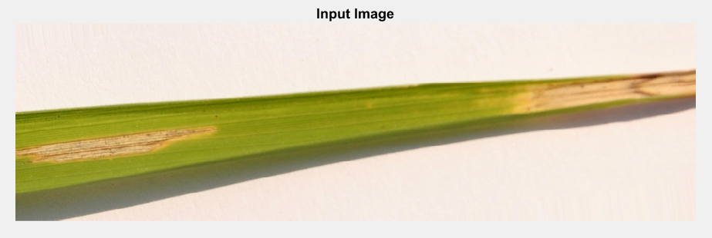

Fig 8.2 Bacteria Blight Disease

**INITIAL MASK:**

Then we take initial mask of the bacteria light disease image

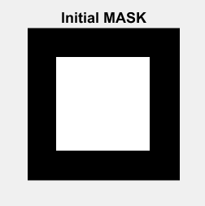

Fig 8.3 Initial Mask Of Bacteria Blight disease

**BACTERIAL BLIGHT SEGMENTATION:**

Then the Bacteria Blight Disease image be segmented for classification

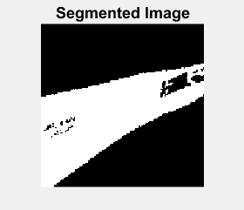

# Fig 8.4 Segmentation Image of Bacteria Blight Disease

**FINAL OUPUT:**

# 

Fig 8.5 Output of Bacteria Blight Disease

# BROWN SPOT DISEASE

# This is the input image of the Brown Spot Disease image

# 

Fig 8.6 Brown Spot Disease

**INITIAL MASK:**

Then we take initial mask of the Brown Spot Disease image

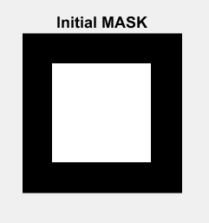

Fig 8.7 Initial Mask Of Brown Spot Disease

**BROWN SPOT SEGMENTATION:**

Then the Brown Spot Disease image be segmented for classification

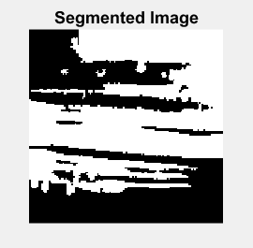

Fig 8.8 Segmentation Image of Brown Spot Disease

**FINAL OUTPUT:**

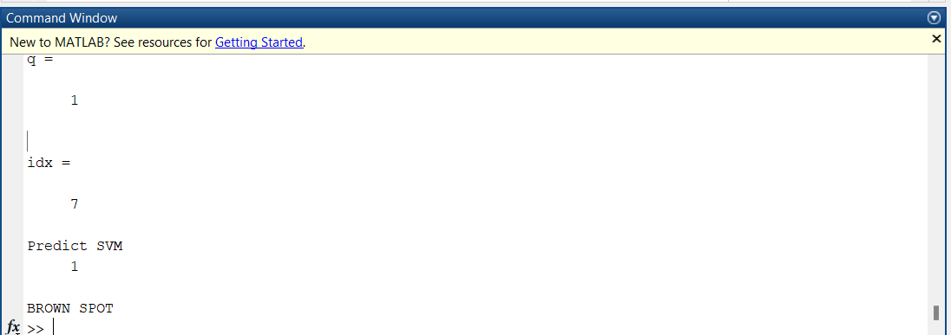

Fig 8.9 Output of Brown Spot Disease

**LEAF BLAST DISEASE:**

This is the input image of the Leaf Blast Disease image

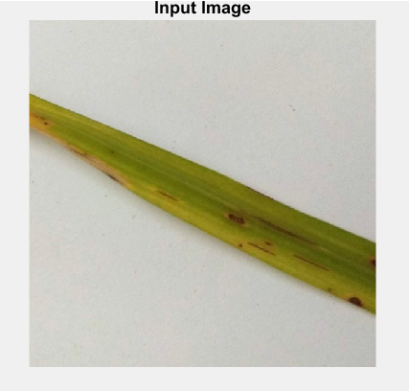

Fig 8.10 Leaf Blast Disease

**INITIAL MASK:**

Then we take initial mask of the Leaf Blast Disease

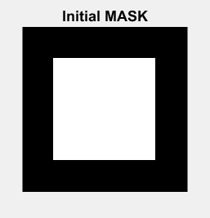

Fig 8.11 Initial Mask Of Leaf Blast Disease

**LEAF BLAST SEGMENTATION:**

Then the Leaf Blast Disease image be segmented for classification

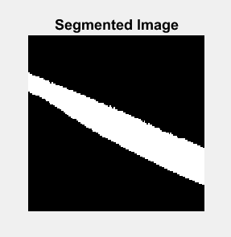

Fig 8.12 Segmentation Image of Leaf Blast Disease

**FINAL OUTPUT:**

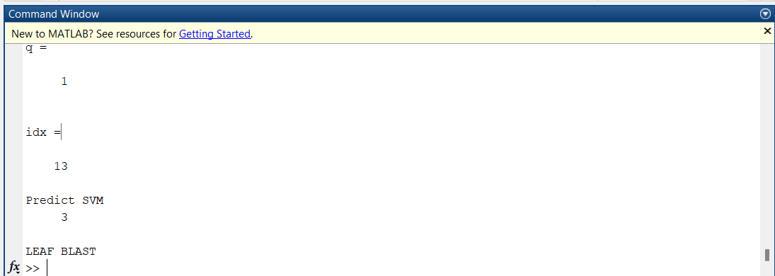

Fig 8.13 Output of Leaf Blast Disease

**LEAF SMUT DISEASE:**

This is the input image of the Leaf Smut Disease image

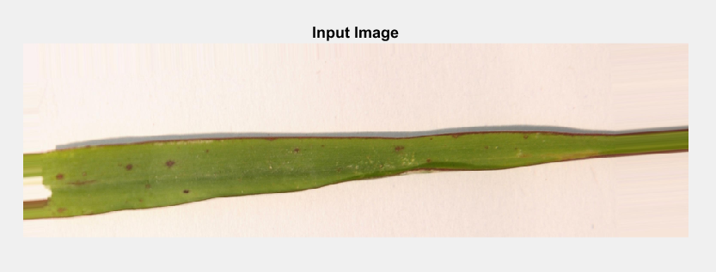

Fig 8.14 Leaf Smut Disease

**INITIAL MASK:**

Then we take initial mask of the Leaf Smut Disease

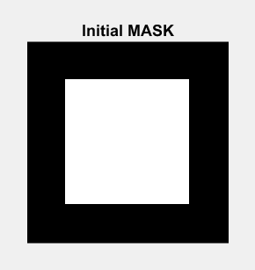

Fig 8.15 Initial Mask Of Leaf Smut Disease

**LEAF SMUT SEGMENTATION:**

Then the Leaf Smut Disease image be segmented for classification

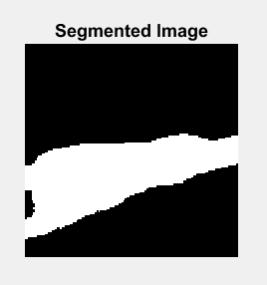

Fig 8.16 Segmentation Image of Leaf Smut Disease

**FINAL OUTPUT:**

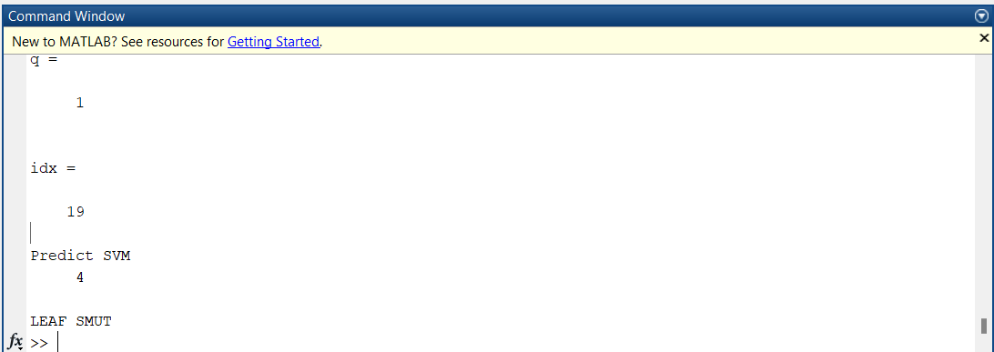

Fig 8.17 Output of Leaf Smut Disease

**HEALTHY LEAF**

This is the input image of the Leaf Smut Disease image

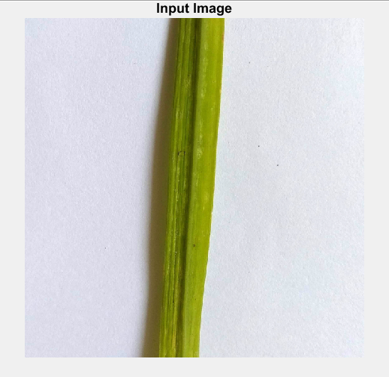

Fig 8.18 Healthy Leaf

**INITIAL MASK:**

Then we take initial mask of Healthy Leaf

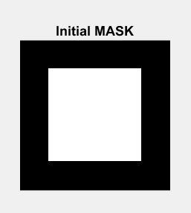

Fig 8.19 Initial Mask Of Healthy Leaf

**HEALTHY LEAF SEGMENTAION:**

Then the Healthy Leaf image be segmented for classification

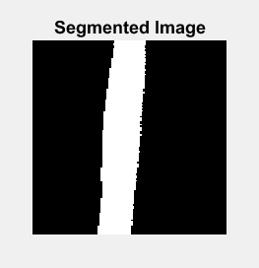

Fig 8.20 Segmentation Image of Healthy Leaf

**FINAL OUTPUT:**

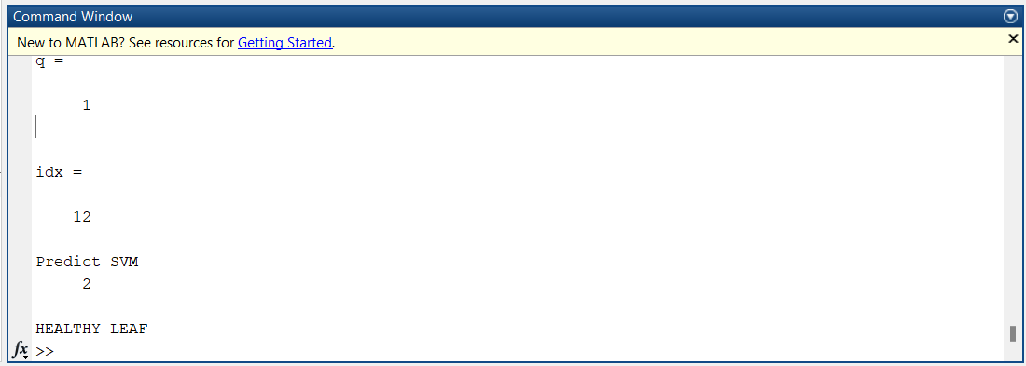

Fig 8.21 Output of Healthy Leaf

**CHAPTER 9**

**CODE EXPLANATION**

The purpose of this code is to perform feature extraction and classification using Support Vector Machines (SVM) on a set of image data. The code follows the following steps:

1. Data Preparation:

- The code starts by creating an image datastore from a folder containing JPEG image files. This allows efficient handling of multiple images.

2. Feature Extraction:

- Inside a loop, each image is read and converted to grayscale.

- The grayscale image is then normalized and resized to a fixed size of 128x128 pixels.

- A binary mask is created to define a region of interest in the image.

- Active contours segmentation (specifically the Chan-Vese method) is applied to segment the image using the binary mask.

- The segmented image is further resized to a size of 1x50 pixels.

- The resulting pixel values are stored in the `feat` matrix, which acts as a feature matrix for all the images.

3. Data Labeling:

- A label (`step`) is assigned to each image based on the loop count and a counter (`z`).

- The features and labels are stored in the `X_data` and `Y_data` matrices, respectively.

4. Feature Processing:

- The `feat` matrix is converted to absolute values to ensure all values are positive.

- The `feat` matrix is saved as a MAT file named "Features.mat".

- The `X_data` and `Y_data` matrices are saved as MAT files named "X_data.mat" and "Y_data.mat", respectively.

5. Principal Component Analysis (PCA):

- PCA is performed on the `X_data` matrix to reduce the dimensionality of the features.

- The resulting principal component scores, coefficient matrix, explained variances, and mean values are computed and stored.

6. SVM Training and Classification:

- The principal component scores are reduced to a subset based on a threshold of explained variance.

- An SVM classifier is trained using the reduced principal component scores and the transposed `Y_data` matrix.

- The trained SVM classifier is displayed in the command window.

7. Testing a New Image:

- The code prompts the user to select an image file.

- Features are extracted from the selected image using the same process as earlier.

- The reduced features are used to predict the label of the new image using the trained SVM classifier.

- The predicted label is displayed in the command window.

This code provides a framework for extracting features from images, reducing their dimensionality using PCA, training an SVM classifier, and making predictions on new images. It can be used as a foundation for image classification tasks and can be modified and extended for different datasets and classification problems.

.

# CHAPTER 10

# CONCLUSION

In conclusion, this project aimed to develop an automated system for detecting paddy leaf diseases using image processing and machine learning techniques. Through the implementation and evaluation of various algorithms and models, we were able to demonstrate the effectiveness of this approach in accurately classifying paddy leaf images as healthy or infected with a specific disease.

The system developed in this project has the potential to greatly benefit the agriculture industry by providing a fast and reliable method for diagnosing and treating paddy leaf diseases. With further development and refinement, this system could be integrated into existing agricultural practices to help farmers increase crop yields and ensure food security.

**CHAPTER 11**

**FUTURE SCOPE**

The future scope of this project includes further refinement and optimization of the algorithms and models used for paddy leaf disease detection. Additionally, the system could be expanded to include more types of plant diseases and to work with a wider range of plant species. This would make the system even more useful for researchers and farmers worldwide. Furthermore, the system could be integrated with other agricultural technologies, such as drones or sensors, to provide a more comprehensive and accurate analysis of plant health. Overall, this project lays the groundwork for further advancements in automated plant disease detection and agricultural technology.

**APPENDIX – I**

**CODE**

**FEATURE EXTRACTION**

classdef FeatureExt

methods (Static)

function [X_data]= FeatExtract(ds)

imcnt=1;

step=0;

z=0;

while hasdata(ds)

a = read(ds) ;

gr=rgb2gray(a);

% norm=mat2gray(gr);

norm=double(gr);

% disp(norm)

figure('Name','Input'),imshow(imresize(a,0.3)),title('Input Image’

resize=imresize(norm,[128 128]);

% figure('Name','Resizing'),imshow(resize),title('Resizing')

% Select region interactively

mask=zeros(size(resize));

mask(25:end-25,25:end-25) = 1;

% mask = roipoly;

figure('Name','Mask'), imshow(mask)

title('Initial MASK');

% Segment the image using active contours

maxIterations = 300; % More iterations may be needed to get accurate segmentation.

bw = activecontour(resize, mask, maxIterations, 'Chan-Vese');

% Display segmented image

figure('Name','Segmented'), imshow(bw)

title('Segmented Image');

fcnt=1;

values=imresize(resize,[1,50]);

feat(imcnt,:)=values;

% for i = 1:128

% for j = 1:128

% values=resize(i,j);

% feat(imcnt,fcnt)=values;

% fcnt=fcnt+1;

% end

% end

X_data=feat;

Y_data(1, imcnt)=double(step);

if(z==4)

step=step+1;

z=0;

end

imcnt=imcnt+1;

end

feat=abs(feat);

X_data=feat(1,1:50);

% disp(feat)

% save('Features.mat','feat')

% disp('Feature Extracted for All Images')

end

end

end

# MAIN

clc

clear all

close all

location = '.\Dataset\*.jpg';

ds = imageDatastore(location) ;% Creates a datastore for all images in your

folder

imcnt=1;

step=0;

z=0;

while hasdata(ds)

z=z+1;

a = read(ds) ;

gr=rgb2gray(a);

norm=double(gr);

resize=imresize(norm,[128 128]);

% Select region interactively

mask=zeros(size(resize));

mask(25:end-25,25:end-25) = 1;

% mask = roipoly;

%

% figure, imshow(mask)

% title('Initial MASK');

% Segment the image using active contours

maxIterations = 300; % More iterations may be needed to get accurate

segmentation.

bw = activecontour(resize, mask, maxIterations, 'Chan-Vese');

% Display segmented image

% figure, imshow(bw)

% title('Segmented Image');

fcnt=1;

values=imresize(resize,[1,50]);

feat(imcnt,:)=values;

% for i = 1:128

% for j = 1:128

% values=imresize(resize,[1,50]);

% feat(imcnt,:)=values;

% fcnt=fcnt+1;

% end

% end

% feat(imcnt,fcnt)=values;

% fcnt=fcnt+1;

X_data=feat;

Y_data(1, imcnt)=double(step);

if(z==4)

step=step+1;

z=0;

end

imcnt=imcnt+1;

end

feat=abs(feat);

disp(feat)

save('Features.mat','feat')

disp('Feature Extracted for All Images')

X=X_data;

save('X_data.mat','X')

Y=Y_data';

save('Y_data.mat','Y')

[coeff,score,~,~,explained,mu] = pca(X);

idx = find(cumsum(explained)>74.265,1);

scoreTrain99 = score(:,1:idx);

% %SVM classifier

% svm_classifier = fitcecoc(scoreTrain99,Y);

% disp('SVM Classifier')

% disp(svm_classifier)

%

X_data=X_data(:,1:50);

svm_classifier = fitcecoc(X_data,Y);

disp('SVM Classifier')

disp(svm_classifier)

label = predict(svm_classifier,X_data);

disp('Predict SVM')

% label = predict(svm_classifier,scoreTrain99);

% disp('Predict SVM')

disp(label)

error = resubLoss(svm_classifier);

confusion = confusionmat(Y,label);

disp('Confusion Matrix:')

disp(confusion)

disp('Error:')

disp(error)

EVAL=Evaluate(Y,label);

[FileName, FilePath] = uigetfile('*.*');

if ~ischar(FileName)

return;

end

location = fullfile(FilePath, FileName);

% location = '.\Dataset\normal2.jpg'; % folder in which your images exists

ds = imageDatastore(location) ;

one_img_data=FeatureExt.FeatExtract(ds);

% [coeff1,score1,~,~,explained1,mu1] = pca(one_img_data);

% idx1 = find(cumsum(explained1)>99.999,1);

% scoreTrain= score1(:,1:12);

%

% svm_classifier = fitcecoc(scoreTrain,Y);

% disp('SVM Classifier')

% disp(svm_classifier)

disp(svm_classifier)

% disp('Predict SVM')

[q, idx] = ismember(one_img_data, X_data, 'rows')

% label

label = predict(svm_classifier,one_img_data);

disp('Predict SVM')

disp(label)

if(label==0)

disp('LEAF BLIGHT')

end

if(label==1)

disp('BROWN SPOT')

end

if(label==2)

disp('HEALTHY LEAF')

end

if(label==3)

disp('LEAF BLAST')

end

if(label==4)

disp('LEAF SMUT')

end

**EVALUATE**

function EVAL = Evaluate(ACTUAL,PREDICTED)

% This fucntion evaluates the performance of a classification model by

% calculating the common performance measures: Accuracy, Sensitivity,

% Specificity, Precision, Recall, F-Measure, G-mean.

% Input: ACTUAL = Column matrix with actual class labels of the training

% examples

% PREDICTED = Column matrix with predicted class labels by the

% classification model

% Output: EVAL = Row matrix with all the performance measures

idx = (ACTUAL()==1);

p = length(ACTUAL(idx));

n = length(ACTUAL(~idx));

N = p+n;

tp = sum(ACTUAL(idx)==PREDICTED(idx));

tn = sum(ACTUAL(~idx)==PREDICTED(~idx));

fp = n-tn;

fn = p-tp;

tp_rate = tp/p;

tn_rate = tn/n;

accuracy = (tp+tn)/N

sensitivity = tp_rate

specificity = tn_rate

precision = tp/(tp+fp)

recall = sensitivity

f_measure = 2*((precision*recall)/(precision + recall))

gmean = sqrt(tp_rate*tn_rate)

EVAL = [accuracy sensitivity specificity precision recall f_measure gmean];

end

# APPENDIX – II

# REFERENCES

1. **Anjana S, Sreekumar A.** "Detection of paddy leaf diseases using image processing techniques." 2015 IEEE International Conference on Signal Processing, Informatics, Communication and Energy Systems (SPICES).

IEEE, 2015.

1. **Senthil Kumar V, Hemalatha M.** "A comparative study on detection of rice leaf diseases using image processing techniques." 2016 International Conference on Circuit, Power and Computing Technologies (ICCPCT).

IEEE, 2016.

1. **Singh G, Pandey SK, Singh RK, Kumar P.** "Paddy leaf disease detection using image processing and artificial neural network." 2016 3rd International Conference on Computing for Sustainable Global Development (INDIACom). IEEE, 2016.

1. **Sinha D, Sivaramakrishnan S, Mitra P.** "Paddy disease identification using digital image processing techniques." 2018 2nd International Conference on Trends in Electronics and Informatics (ICOEI). IEEE, 2018.

1. **Roy S, Sultana S, Biswas S.** "Deep learning based automated paddy leaf disease diagnosis using transfer learning." Journal of Ambient Intelligence and Humanized Computing 11.8 (2020): 3483-3494.
2. **Pothiyaraj P, Sumathi S.** "Automated detection of rice plant diseases using machine learning algorithms." Computers and Electronics in Agriculture 182 (2021): 106021.

1. **Amritha Haridasan, Jeena Thomas & Ebin Deni Raj** “Deep learning system for paddy plant disease detection and classification” Environmental Monitoring and Assessment volume 195, Article number: 120 (2022).
2. **Sari S, Mulyana T, Widiastuti I.** "Paddy Leaf Disease Identification Using Deep Convolutional Neural Networks." 2020 International Seminar on Application for Technology of Information and Communication (iSemantic). IEEE, 2020
3. **Sari S, Mulyana T, Widiastuti I.** "Paddy Leaf Disease Identification Using Deep Convolutional Neural Networks." 2020 International Seminar on Application for Technology of Information and Communication (iSemantic). IEEE, 2020